Legacy Works: Visual Arts and Reminiscence
for Older Adults

A new program manual from the National Center for Creative Aging / Elders Share the Arts

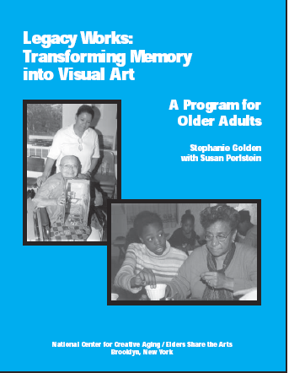
Legacy Works is a simple, flexible, yet powerful and profound program that engages elders in reminiscence and storytelling, evoking memories that they transform into vibrant, moving visual artworks. The program trains teenagers, adult volunteers, or home care aides as helpers who learn oral-history interviewing and art skills, then work with the elders to elicit their memories and create collages, prints, drawings, paintings, assemblage, and other artworks. The program closes with a gala exhibit of the art for the seniors’ whole community.
This manual enables administrators and staff of hospitals, nursing homes, home-care agencies, and senior centers who serve frail, homebound, and well elders to set up and run Legacy Works programs with their own personnel and volunteers. It explains how to adapt Legacy Works for your own situation, then takes you step-by-step through the entire process of planning, implementation, and evaluation. Appendices offer a variety of program tools to photocopy and hand out.

- $18.00; 80 pages with photos
- Includes single-sheet handouts of illustrated, step-by-step instructions for 9 simple visual art projects
- Extensive list of oral-history questions
- Recruiting handout

“If our character is based on the accumulation of our experiences, stories from our elders are true gifts. Elders Share the Arts is all about dipping into that river of memory and experience.”
—Jane Alexander, former chair, National Endowment for the Arts
The National Center for Creative Aging / Elders Share the Arts is an innovator in the emerging field of arts and aging. Elders Share the Arts, an award-winning community arts organization, has conducted its model “Living History Arts” programs for older adults since 1979. The National Center for Creative Aging, a networking, advocacy, and resource center, trains professionals around the country in the theory and practice of running quality arts programs for older adults.

National Center for Creative Aging / Elders Share the Arts
138 South Oxford Street
Brooklyn, NY 11217
Phone: (718) 398-3870 Fax: (718) 857-3864
www.elderssharethearts.org and www.creativeaging.org.

